The 2016 Pacific Coast Dream Machines Show Returns
Sunday April 24, 2016 to Half Moon Bay Airport
The “Coolest Show on Earth”
By Tony Leopardo © AutoWire.Net

THE COOLEST SHOW ON EARTH ROLLS INTO HALF MOON BAY

The Pacific Coast Dream Machines Show Returns Sunday, April 24, 2016 to Half Moon Bay Airport with more World-Class Tricked-Out Cars and Trucks, Fantastic Flying Machines, Custom Motorcycles, Quirky Contraptions, and the Dream Machine of the Year Award to Headline The Coolest Show on Earth. Plus Freestyle Motocross Stunt Shows, Monster Truck Rides, Unimotorcycle Drag Racing, Spectacular Skydiving and the World’s Youngest Monster Truck Driver Debut!

Half Moon Bay California's Festival of Magnificent Machines Marks 26th Year
HALF MOON BAY, CALIFORNIA - There are car shows, air shows, motorcycle shows, tractor shows, maker fairs, music festivals, food festivals, and living history festivals galore. Mix them all together in one venue on one day and you’ve got Half Moon Bay California’s remarkable, one and only Pacific Coast Dream Machines Show, marking its 26th year in 2016 with a massive celebration of mechanical ingenuity, power and style.
It's quite simply the “Coolest Show on Earth”. This year’s spectacular 26th annual show will be held on Sunday, April 24, a one-day mega-show, from 10 a.m. to 4 p.m. at Half Moon Bay Airport, located in the picturesque seaside town of Half Moon Bay, CA about 20 miles south of San Francisco.
It's a whimsical, fascinating, amusing, curious and absolutely unique show and tell spectacle featuring 2,000 magnificent driving, flying and working machines from the 20th and 21st centuries. The world's coolest cars of every era and style, model-T fire engines, vintage busses, custom motorcycles, tricked out trucks, sleek streamliners, one-of-a-kind antique engines and tractors and historic military aircraft will be among the mesmerizing displays.

SPECIAL ATTRACTIONS FOR 2016 - Debuting this year are spectacular skydiving performances from the C-47 Skytrain with military style jumps by the experts at Precision Skydiving and a special appearance by Shane Skull Krusher, the world’s youngest mini monster truck driver. For electrifying showstoppers, the show's extreme attractions return, freestyle motocross shows, unimotorcycle drags and monster truck rides plus helicopter, plane rides and vintage warbird flyovers.

THE WORLD’S COOLEST CARS - It's one of the west coast's biggest, baddest gatherings of the world's coolest cars. Spectators will get a rare up-close look at antique horseless carriages and Ford Model T's, fanciful touring and luxury cars, powerful sports cars, custom cars and street rods, muscle cars, vintage and modern era high-performance race cars, quirky art and pedal cars, modified street machines with cutting edge styles, exotic high-performance cars, stylish European cars, ultra cool low-riders, sporty compacts, modified imports with flashy graphics, fashionable hip-hop urban show cars, homebuilt kit cars, super-charged turbo cars and trucks, “green” technology/alternative fuel vehicles, streamliners, dragsters, funny cars, gassers, and jet cars.

FANTASTIC FLYING MACHINES
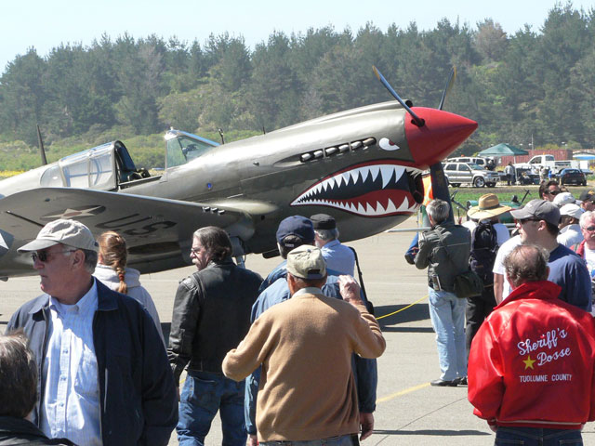
Hundreds of aviation wonders are expected to be on display, headlined by legendary vintage warbirds like the B-25 Bomber and C-47 Skytrain plus stylish homebuilts, classics from the ‘40s and ‘50s, sport and ultralight aircraft. Inspiring flyovers by some of our nation’s most storied military aircraft promise to be a fan favorite, all flown in memory of the late Eddie Andreini Sr., world-renown aerobatics pilot, founding Dream Machines contributor and pillar in the Half Moon Bay community. Plus there's P-51 “Mustang Madness”, a spectacular display of America’s premier World War II fighter along with YAK Russian fighters and an impressive array of T-6 and T-28 military fighters and trainers. Thrilling rides will be offered in helicopters and vintage bi-planes.

DREAM MACHINE OF THE YEAR AWARD - The "DRIVE Magazine Dream Machine of the Year" returns with editors from Beckett Media’s DRIVE Magazine on hand to select a winner from the thousands of magnificent machines on display. A special trophy will be awarded at a recognition ceremony during the show.
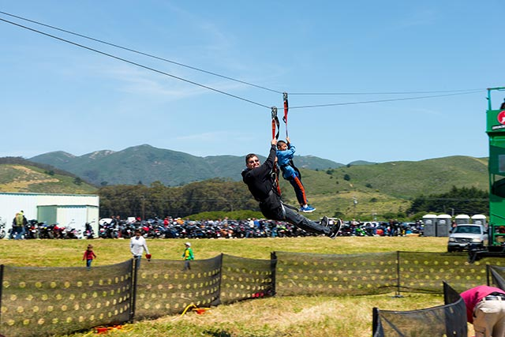

SUPER DUPER KIDZ FUNZONE - The attractions for youngsters are awesome and endless in the Super Duper Kidz Funzone: an ultra-thrilling zip line, Zorbs, the Human Hamster Ball race track, bungee jump, rock climbing wall, wild and wacky waterballerz, Rocky the Mechanical Bull ride, giant inflatable rock slide and obstacle course, face painting, and a remote-controlled NASCAR race track.

FABULOUS FOOD AND DELICIOUS DRINK - There will be plenty of delectable food and delicious coastal-infused drink with a custom cocktail and beer just for the show, The Aviator, a refreshing gin cocktail and Bloody Mary’s from Half Moon Bay Distillery and Classic Motorhead Ale from Half Moon Bay Brewing Company plus tasty varietals from Half Moon Bay’s Barterra Winery.

SMASHING ENTERTAINMENT - The sensational all-day music lineup features featuring headliners East Bay Mudd, the Chris Cain Band, and the Andy Santana Band with surprise guests. Special thanks to music organizer Grant Walters for his longtime support.

SATURDAY HANGAR DINNER - The Half Moon Bay Pilots Association Saturday Hangar Dinner will be held on Saturday, April 23 at the Andreini family hangar at Half Moon Bay Airport. Preview some of the historic aircraft and custom cars that will be displayed at the Dream Machines Show and enjoy a festive barbecue tri-tip dinner party. Tickets are $30 per person, available at the door which open at 5:30 pm. Parking is on the airport field, enter off Capistrano Road.

MOBILE APP + FREE WI-FI - Download the free Dream Machines mobile app developed by Half Moon Bay’s Phondini Partners. This fantastic app is designed to enhance the event experience for users by providing everything from a fact sheet with key details, information on special attractions, a detailed site map keyed to specific attractions, event and entertainment schedule, door-to-door directions, push messaging alerts, social media integration, and visitor information via a full-function version of Phondini's iCoastside app. The app, scheduled to be available in mid April, is available for the Apple and Android markets. Free Wi-Fi will be provided throughout the festival area by the good folks at www.Coastside.net.
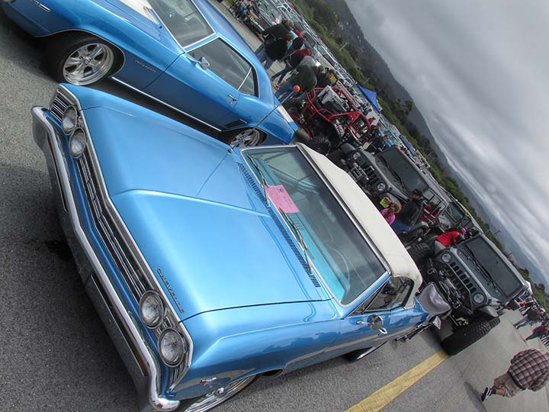

REGISTER YOUR MACHINE - To show a car, the registration fee is $40 ($50 for entries postmarked after April 15) and includes a dash plaque and admission for two people. Register online.

SPECTATOR ADMISSION - Spectator admission is $25 for adults (age 18-69), $15 for ages 11-17 and 70+, Free for kids age 10 and under. Tickets are available at the gate only.

PARKING - Vehicle and bicycle parking on the airport grounds is included in the price of admission. Click here for the event map.

HANDICAPPED PARKING - There will be specially marked handicapped parking on the airport grounds. Attendants will be on-site to direct you. Click here for the event map.

FIRST AID/LOST & FOUND - First aid and lost and found is located at the Information Booth – please refer to the event site map. Click here for the event map.

SHUTTLE BUS - A special shuttle bus is available to shuttle visitors from the auto display areas at the central/south end of the airport to the aircraft display area at the north end. Click here for the event map.

NO PETS, PLEASE - Please be considerate. For the safety, comfort, and courtesy of your pets and festival-goers, please leave your pets at home. Large crowds and noise make it a very stressful and dangerous environment for pets.

DATES/HOURS - The show is open to the public on Sunday, April 24 from 10 am to 4 pm. Gates open at 6:30 for those that have registered their machine or plan to register the day of show.

EVENT LOCATION - Half Moon Bay Airport, at 9850 N. Cabrillo Highway, is located on Highway 1, about 20 miles south of San Francisco and 5 miles north of Highway 92. Get directions.

EVENT BENEFICIARY - The show benefits the Coastside Adult Day Health Center. Thanks in part to fund-raising support from Dream Machines, the sparkling new Coastside Adult Community Center opened in 2014. Drop by the fabulous new facility shared with Senior Coastsiders at 925 Main Street in Half Moon Bay.

INFO-LINE/WEB/SOCIAL MEDIA - For event information and registration forms, call the info-line at 650-726-2328 or visit the website. “Like” our Facebook page or follow us on Twitter and Instagram.

The 26th Annual Pacific Coast Dream Machines Show Review: provided by:
Tony Leopardo © AutoWire.Net “Tony the Car Guy” is an automotive writer, editor and publisher in the San Francisco Bay Area. If you have a question or comment for Tony send it to TonyLeo@pacbell.net or visit AutoWire.Net at www.autowire.net - And remember: “ You Are What You Drive © ”

Column Name: The “Coolest Show on Earth”
Topic: The 26th Annual Pacific Coast Dream Machines Show
Word Count: 1,458
Photo Caption: The 2016 Pacific Coast Dream Machines Show
Photo Credits: Miramar Events Internet Media
Series #: 2016- 06

